Neural Network
x1 = 2
x2 = 1
w1 = 0.4
w2 = 0.6
b = -0.2

Q1.
=> to calculate the output(y) the formula is:
= (x1*w1)+(x2+w2)+b
= 0.8+0.6-0.2
= 1.2

Q2.
=>

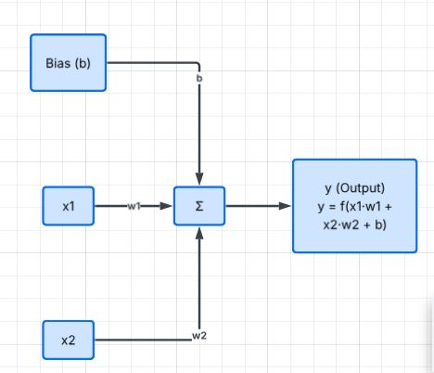

Q.3
=>if the both weight get double then, the final o/p also get double

- Inferencing:
A model needs 2 GB to store and a total of 8 GB is present; then how many model copies can run at a time, ignoring the overload on the system
Q.1
=>Total memory/model total memory
= 8GB/2GB
= 4 copies can run at once
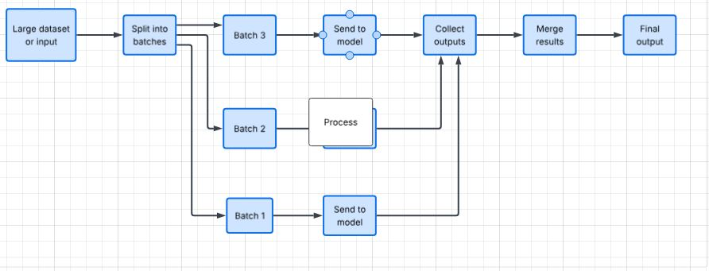
Q.2
=>
Q.3
=> it can run multiple batches at once by simply merging them and running them on the GPU with different weights by forming their layer matrix instead of running one layer at a time.

- LLMS:
Take the sentence "Attention lets the model focus on relevant words.”
Q.1
=> Attention, lets, the, model ,focus on, relevant, words
8 words = 8 tokens

Q.2
=>

Q.3
=> Attention for transformers is the method that makes the system focus on a single task at a time.

- LinkedIn:
We're Hiring | Al Engineer - Fresher

Aptino, Inc. is looking for fresh graduates / 0-1 year professionals passionate about building a career in Al & Generative Al.

Location: Viman Nagar, Pune

Work Mode: Work From Office

Experience: 0-1 Year

Joining: Immediate Joiners preferred

Key Skills: Python | AI/ML | GenAI | Agentic Al | MLOps |
LLMs | AI Frameworks

Who Can Apply?
Recent graduates in CS, AI/ML, Data Science, or related fields
Candidates with relevant internships or Al/ML projects preferred
Strong interest in emerging Al technologies

Share your updated resume:
aditi.akulwar@aptino.com

My Current Status:
So I am not prepared for this job. I haven't learned about Gen AI, agentic AI, or MLOps, and I haven't built projects with them yet. But I also haven't studied it by myself.

Also I did’nt go for any exp…..

